Ideation Phase
Empathize & Discover

Date | 13 July 2026
Team ID | SWTID-2026-4732
Project Name | India's Agricultural Crop Production Analysis
Maximum Marks | 4 Marks

Empathy Map Canvas:

Person : 1
As a small-scale farmer, I want to improve crop productivity and increase my income by selecting the most suitable crops for each season. I believe historical agricultural data and seasonal trends can help me make better farming decisions. However, the available information is complex and difficult to understand, making crop planning challenging. I rely on advice from experienced farmers, market updates, and government recommendations. An interactive Tableau dashboard would provide clear insights and help me make confident, data-driven farming decisions.
Template:
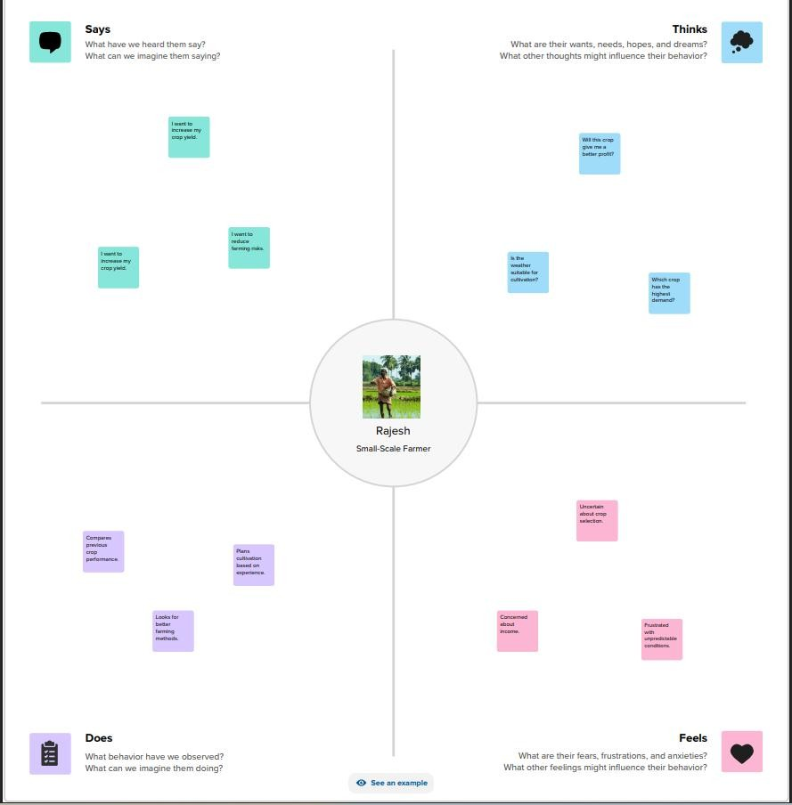

PERSON:
As a Government Policy Analyst, I aim to improve agricultural productivity by developing effective policies and allocating resources efficiently. I believe that accurate and interactive data analysis is essential for identifying low-performing regions and understanding long-term production trends. However, agricultural data is scattered, complex, and difficult to visualize, making policy planning more challenging. I depend on reports, research, and stakeholder feedback to make informed decisions. An interactive Tableau dashboard would enable better analysis and support evidence-based policy development.
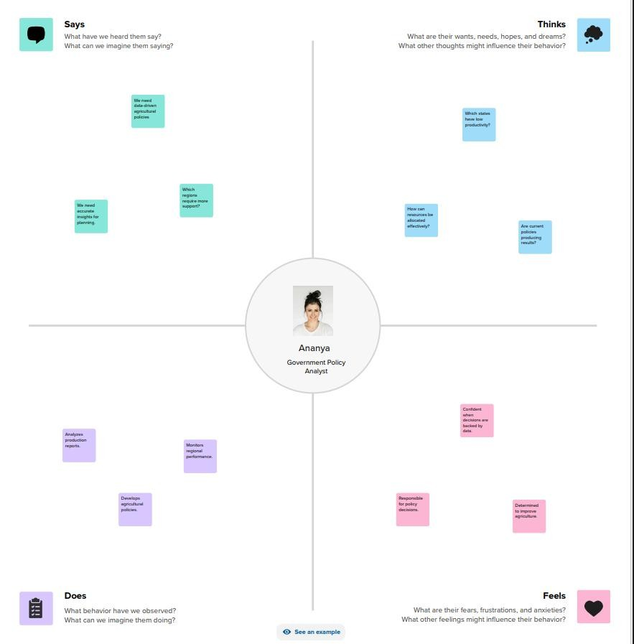
PERSON :
As an agribusiness investor, I seek profitable investment opportunities by analyzing crop production trends, regional performance, and historical agricultural data. I believe reliable insights can reduce investment risks and improve decision-making. However, scattered and complex data makes it difficult to identify high-growth opportunities. I rely on market reports, government policies, and expert recommendations to evaluate investments. An interactive Tableau dashboard would help me identify profitable crops and regions, enabling confident and data-driven investment decisions.
